Resume of
Tanjibur Rahaman

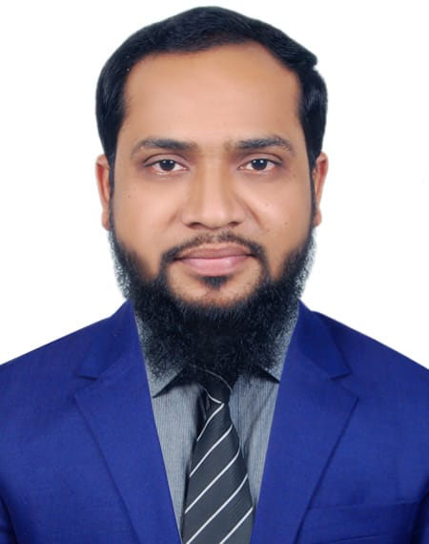
C/O, Mahbubul Hoq , Dharmapur, Feni Sadar, Feni, Bangladesh.
Phone +88-01820-257047,01610-257047.
Email: tanjib_rahaman@hotmail.com
tanjibrahaman1989@gmail.com
Objectives:

To work in a dynamic position which will provide me with an opportunity to utilize and develop my ability, skill and qualification as to take the challenge of the day.

Career Summary:

• TVS Auto Bangladesh Ltd.
Executive – A & F (October 20, 2019 - Continuing)
Company Location : 304,Tejgaon I/A, Dhaka-1215, Bangladesh.
Department: Accounts & Finance.

• RIA International Co.
Accountant, (May 03, 2018 – October 19, 2019)
Company Location: (8th Floor) Lal Bhaban, 18 Rajuk Avenue, Motijheel C/A, Dhaka, Bangladesh.
Department: Accounts & Finance.
• HB Enterprise
Accountant (April 09, 2016 - April 30, 2018)
Company Location : 2/E, Monipuri Para, Sangshad Avenue, Dhaka, Bangladesh.
Department: Accounts & Finance.

Employment History:

• TVS Auto Bangladesh Ltd.
Executive – A & F (October 20, 2019 - Continuing)
Company Location : 304,Tejgaon I/A, Dhaka-1215, Bangladesh.
Department: Accounts & Finance.

- Cash management and Stock management.
- Posting all transactions in SAP.
- Making Sales Report , Expense Report, Inventory Report daily and Monthly basis.
- Submitting all types of report to Head Office.
- Maintain Mushak 6.1, Mushak 6.2, Mushak 6.3 .
- Going to bank regularly to deposit PO/Cheque or any other task.
- Reconciling the branches sales ledger and collection from dealer’s ledger statement monthly.
- Communicating with sales person regularly to match dealer ledger balance.
- Renewal of fire license and trade license after end of the every financial year.
- Perform any other duties and responsibilities assign by the management from time to time.

• RIA International Co.
Accountant, (May 03, 2018 – October 19, 2019)
Company Location: (8th Floor) Lal Bhaban, 18 Rajuk Avenue, Motijheel C/A, Dhaka, Bangladesh.
Department: Finance and Accounts

Duties/Responsibilities:

- Preparation of L/C (Sight & Deffered) for import.
- Renewal of Trade license, IRC and CC Loan A/C.
- Maintain books of accounts.
- Preparation of all vouchers (Receivables and payables).
- Preparation of monthly salary sheet.
- Collection of the receivable amount.
- All Bank related jobs.
- Preparation of all tender documents.
- Maintain stock register, delivery challan file, attendance register, leave summary report, cheque register & cheque book.
- Maintain and Solve VAT and Tax related issues.
- Other accounts & finance related works.

• HB Enterprise
Accountant (July 01, 2015 - April 30, 2018)
Company Location : 2/E, Monipuri Para, Sangshad Avenue, Dhaka, Bangladesh.
Department: Finance & Accounts

Duties/Responsibilities:

- Preparation of accounts statements, maintain of Cash and Bank Book.
- All Bank related jobs.
- Various statements relating to accounts.
- All Raw Materials Purchase.
- Maintain liaison with Supplier Company.
- Preparation of all vouchers (Receivables and payables).
- Preparation of monthly salary sheet.
- Collection of the receivable amount.
- Maintain stock register, delivery challan file, attendance register, leave card and leave summary report, cheque register & cheque book and supplier ledger.
- Checking all supplier bills.
- Other accounts & finance related works.

Cost And Management Accountant (CMA):

Knowledge Level | Subject
Knowledge Level | Principles of Accounting | Passed
Knowledge Level | Principles of Business and Economics | Passed
Knowledge Level | Business Communications | Passed

Business Level | Subject
Business Level | Fundamentals of Financial Accounting | Passed
Business Level | Fundamentals of Management Accounting | Passed
Business Level | Fundamentals of Business Mathematics | Passed
Business Level | Fundamentals of Business Economics | Passed
Business Level | Fundamentals of Ethics, Business Law and Corporate Governance. | On going

Session : 2017-18
Institution : The Institute of Cost and Management Accountants of Bangladesh

Academic Qualification:

Master of Business Studies (MBS):

Passing Year : 2015
Session : 2011-12
Result : 2nd Class (55% Marks)
Major : Accounting
Institution : Dhaka College,Dhaka

Bachelor of Business Studies (Hon’s):

Passing Year : 2014
Session : 2007-08
Result : 2nd Class (54% Marks)
Major : Accounting
Institution : Dhaka College,Dhaka

Higher Secondary School Certificate (HSC):

Passing Year : 2007
Group : Business Studies
Result : GPA 4.10(Out of 5)
Institution : Adhaypak Abdul Mazid College
Educational Board : Comilla

Secondary School Certificate (SSC):

Passing Year : 2005
Group : Business Studies
Result : GPA 4.31 (Out of 5)
Institution : Dharmapur Amin Uddin High School
Educational Board : Comilla

Computer Skills:

- Familiar in accounting software SAP.
- MS-Office(Excel,Word,Outlook)
- Good typing speed in English and Bangla in AVRO.
- Email, Installation of software etc.

Language Proficiency:

Language | Reading | Writing | Speaking
Bangla | High | High | High
English | High | Medium | Medium

Personal Details:

Father’s Name : Mahbubul Hoq
Mother’s Name : Sakhina Sultana
Address : Village-Dharmapur, Post-Feni, P.S- Feni, District-Feni
National ID : 3012923278163
Date of Birth : 1 January, 1989
Marital Status : Married.
Nationality : Bangladeshi

Interest & Hobbies:

Reading books, Watching movie, Travelling, Communicating with others, meeting and contacting people.

References:
Md. Arifur Rahaman |  | Abu Syed Md. Zakaria Hossain
First Assistant Vice President | Senior Officer
EXIM Bank Ltd | Southeast Bank Ltd
+8801797-120343 | +8801819084378  Email:asmzakariah@gmail.com
Signature


………………………………
Tanjibur Rahaman

